Australia’s Physical Features

Coral Sea

Off the northeast coast of Australia. It includes the Great Barrier Reef.

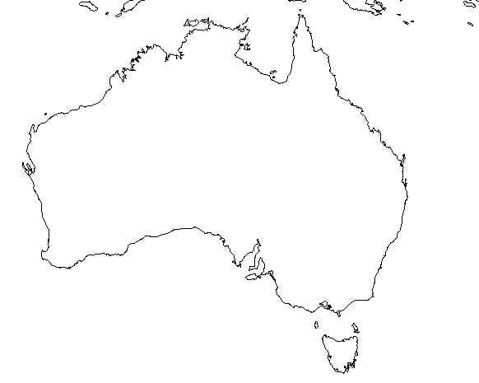

Great Barrier Reef

Amazing underwater world. The largest of its kind in the world. It extends 1,200 miles. More than 1,500 different types of fish live along the reef

Great Victorian Desert

Largest desert in Australia, it is named after England’s Queen Victoria

Ayers Rock

Also called Mount Uluru, it is Australia’s most famous landmark. It is a monolith and it is red sandstone located in the center of Australia. It is considered sacred to the Aborigines